Your Belfast Rewards app features:

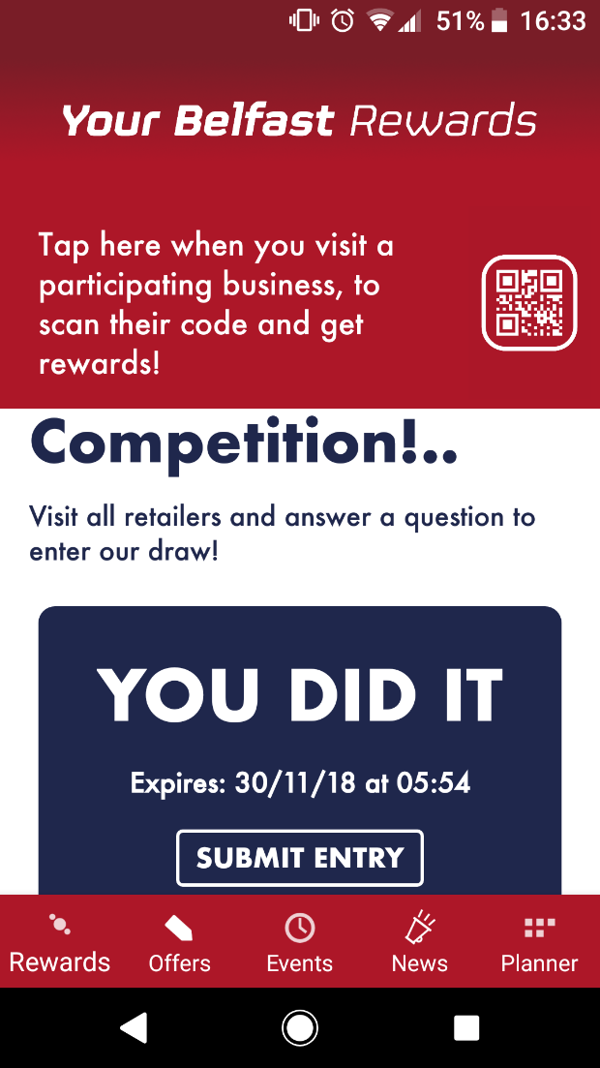 | Features   Rewards  The main area of the app. Daily competitions and prizes.   Offers  Money-off offers and discounts.   Events  A full calendar of all city centre festive entertainment.   News  Relevant updates, for example shops opening on 3 December. Unforeseen updates.   Planner  Users can add events to their planner and get reminders.

